**Team Member**

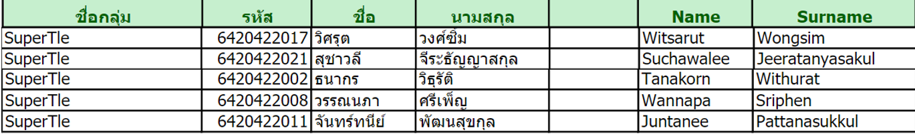

**1. Implementing Word2Vec**

In this part you will implement the word2vec model and train your own word vectors with stochastic gradient descent (SGD). Numpy methods could be utilized to make your code both shorter and faster. The following requirements should be satisfied:

* a) Negative sampling loss
* b) Implement the skip-gram model from scratch
* c) Train with real-data
* d) Show the resulting embeddings

Numpy with negative sampling loss

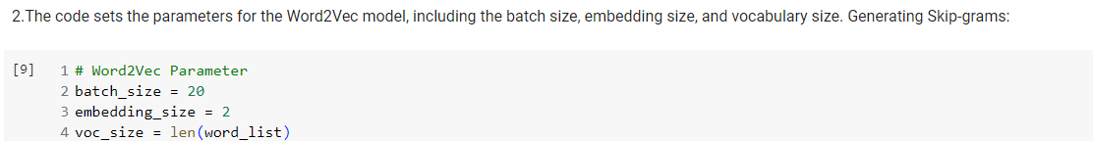

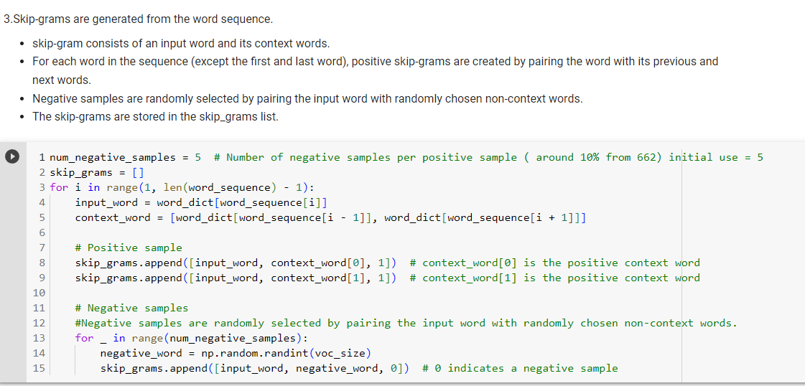

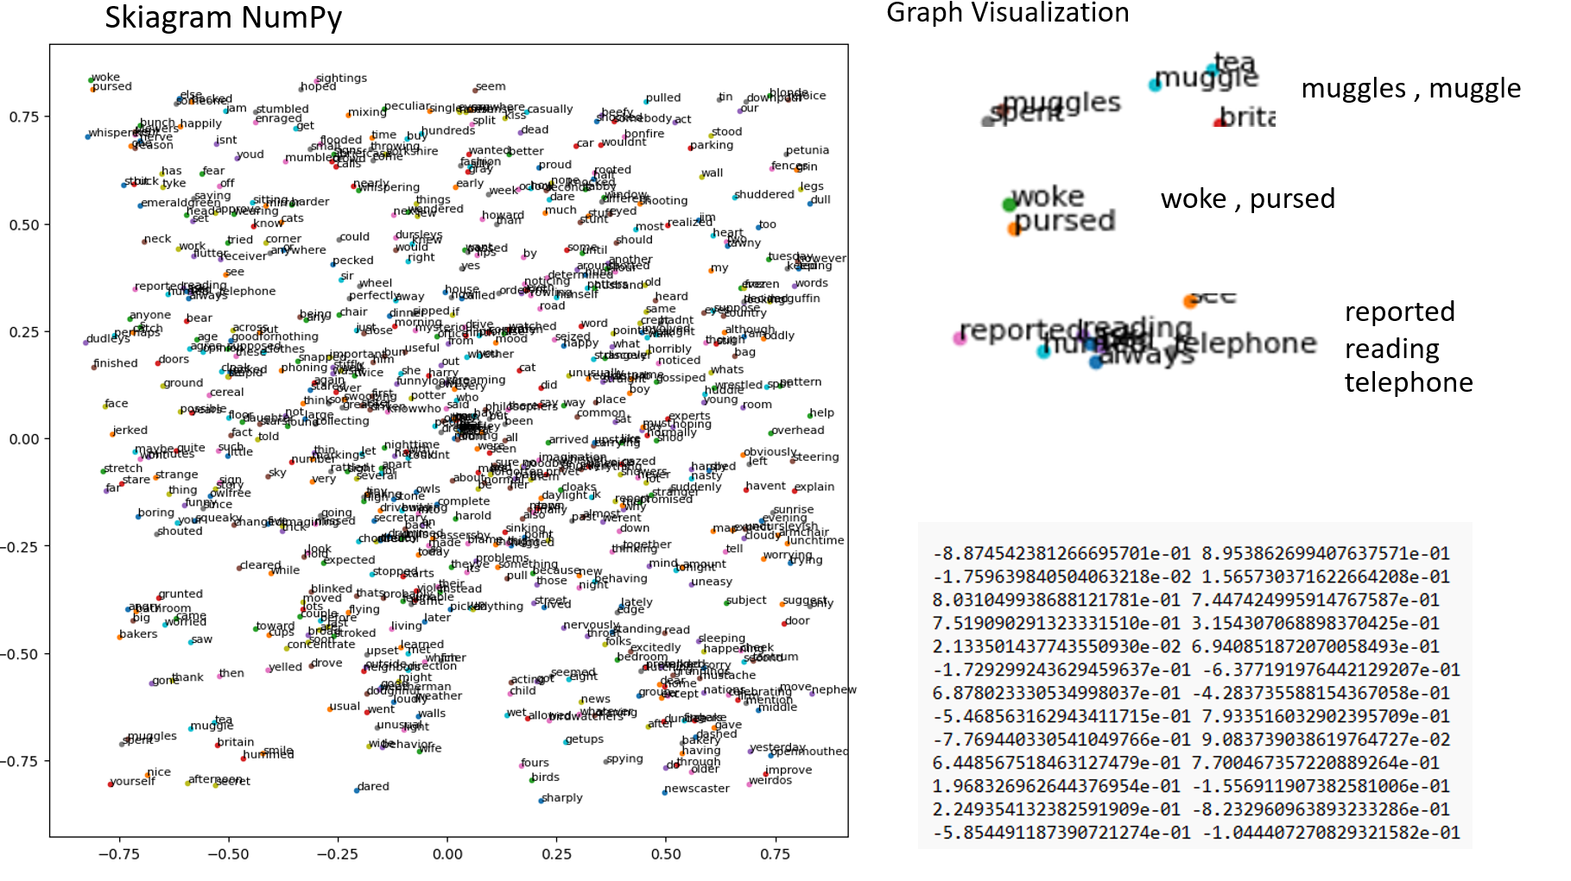

2.Tenserflow with negative sampling loss

Model Workflow

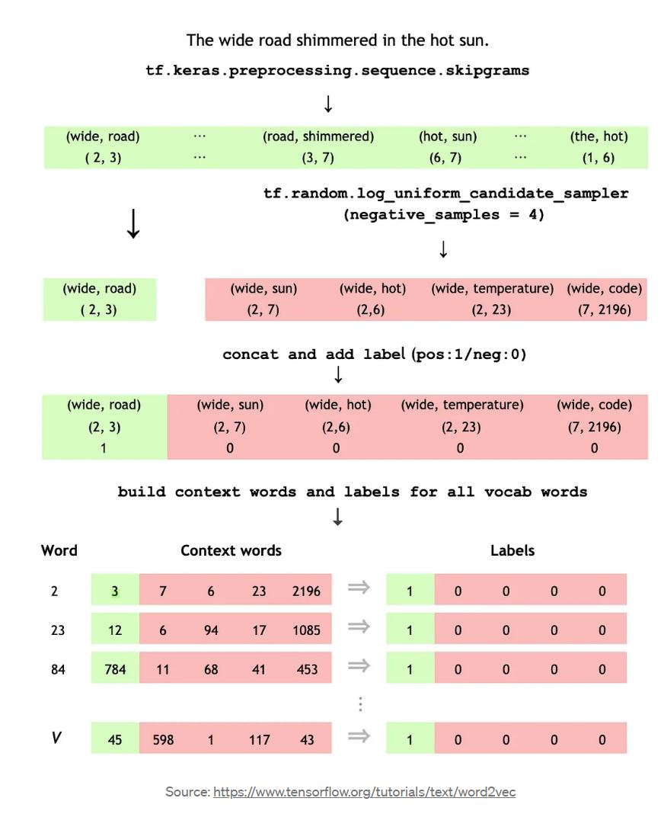

Get data and clean

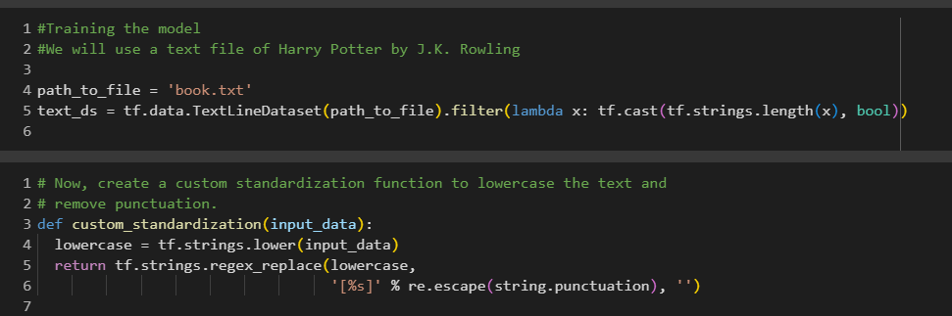

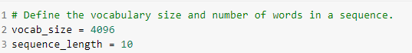



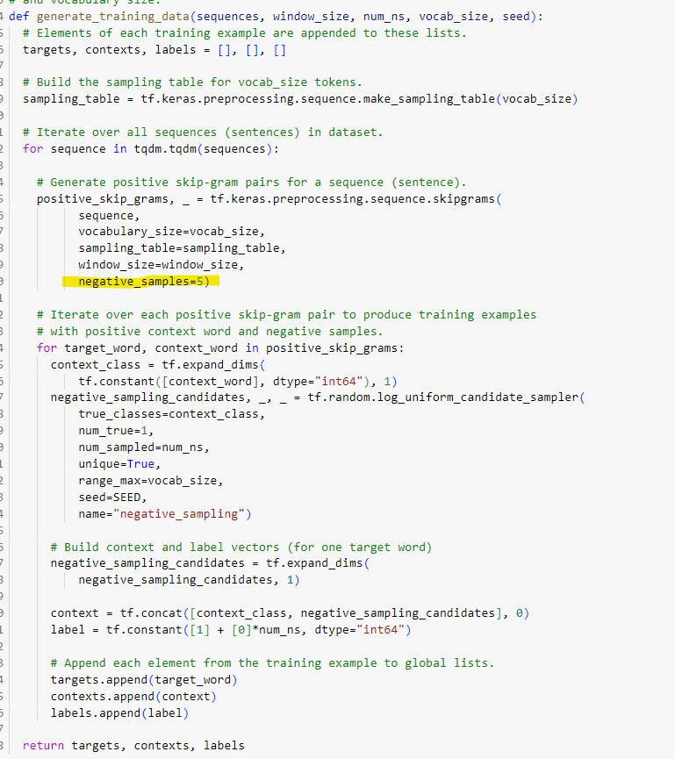

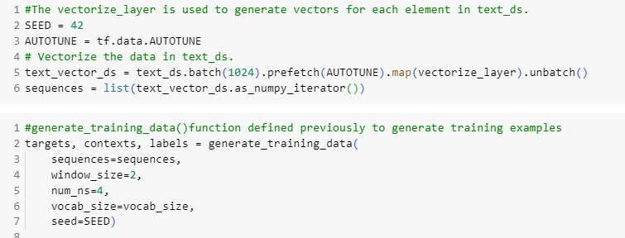

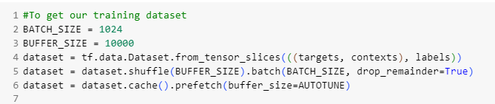

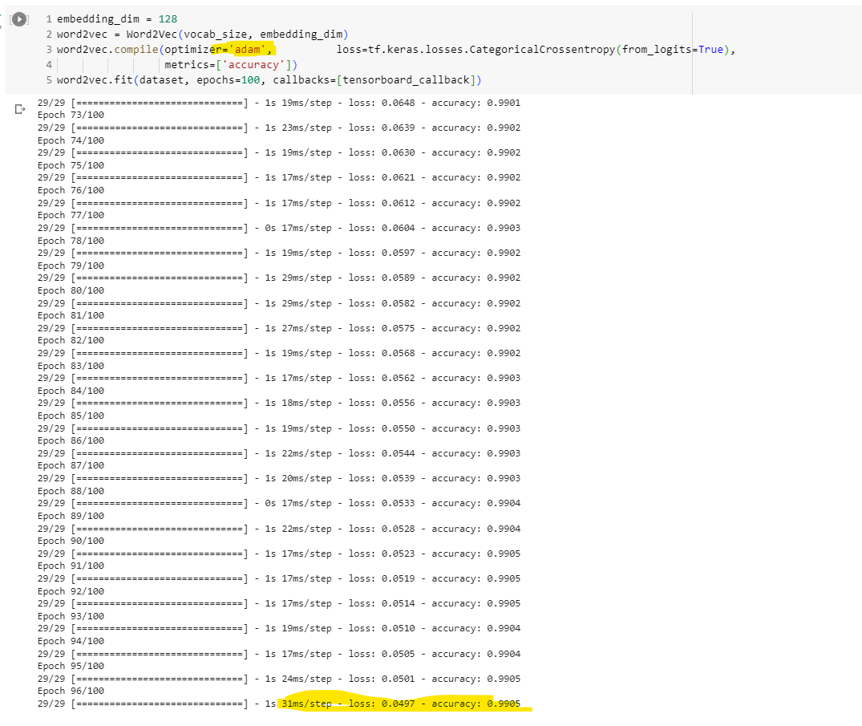

Epoch100 loss: 0.0482 - accuracy: 0.9904

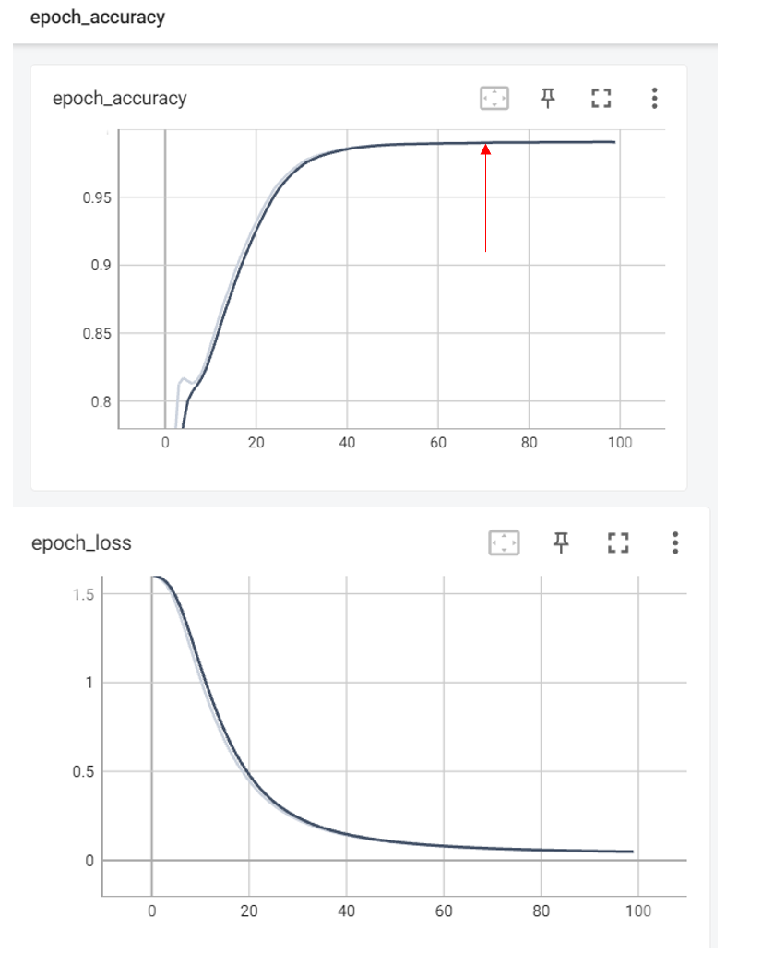

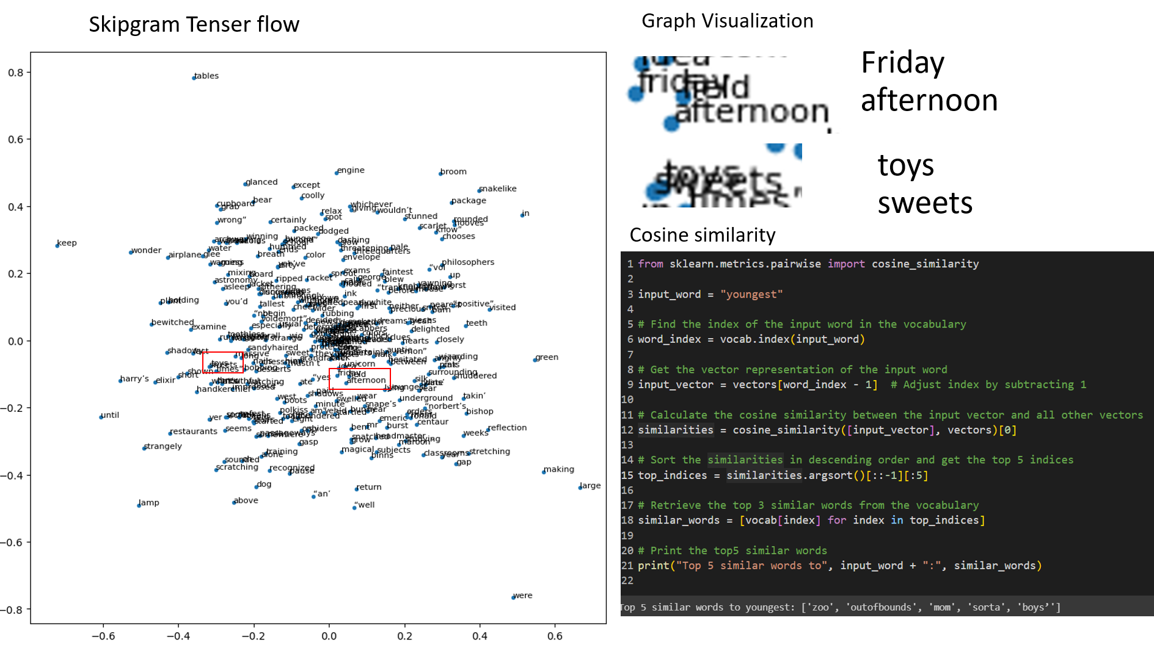

input_word = "youngest"

Top 5 similar words to youngest: ['zoo', 'outofbounds', 'mom', 'sorta', 'boys’']

3D plot

